**The Application of A Physics-based Invers Modeling Approach in Building Energy Model Calibration**

**Abstract**

This paper presents a study of hybrid building energy model calibration using physics-based inverse algorithms.

**Introduction**

This report presents the technical details of the inverse modeling approach in the building energy model calibration

* Building energy consumption…
* Use of building energy modeling and the importance of accurate models…
* Existing research and practices in building energy model calibration…
* Hybrid model calibration proposed by this study…

**Problem formulation**

**Hybrid Model Calibration**

A Comparison of Traditional Manual Calibration and Hybrid Model Calibration with Inversed Balance Equations in EnergyPlus is conducted to

Identify an EnergyPlus model (a DOE reference model or a real building model)

Conduct traditional model calibration and record performance

Use the hybrid method in the calibration

3.1. Initial calibration using traditional approach

3.2. Run inversed models to determine unknown parameters

3.3. Use the calculated parameters from 3.2 in the traditional calibration and re-run it.

3.4. Repeat this process as needed.

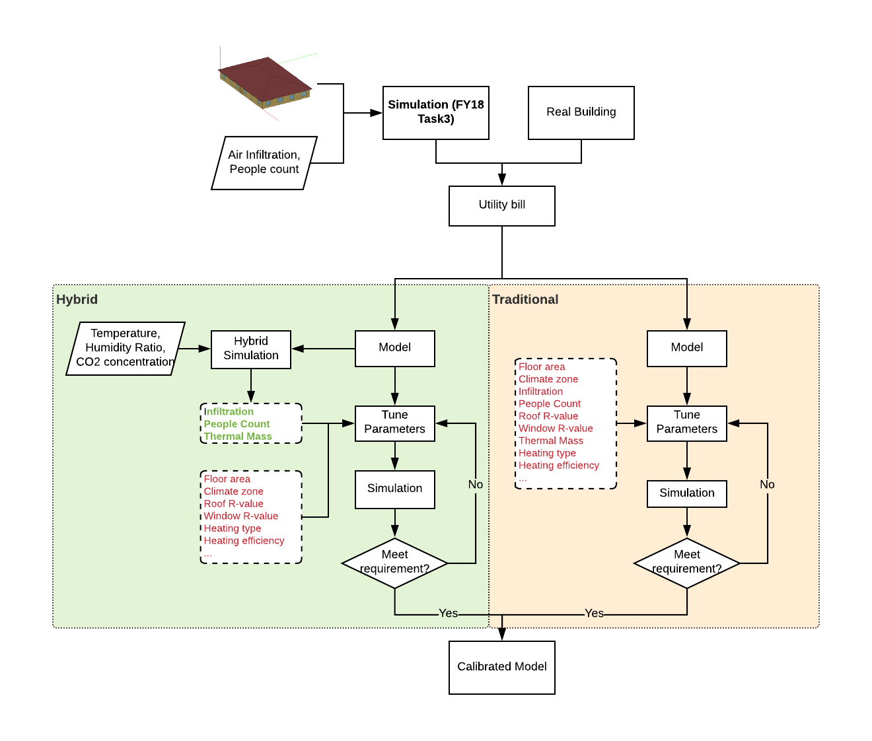

**Experiment**

**Results and Discussions**

**Conclusion**